CSI: Board resolution on changing the brand identity information
On 30 Jun 2020, Viet Nam Construction Securities Joint Stock Company announced the Board resolution on changing the brand identity information as follows:
Article 1: Approve the change in some brand identity information of Vietnam Construction Securities Joint Stock Company and amending and supplementing relevant contents as prescribed in the Company's Charter as follows:
1. Approving the change in the abbreviated name of the Company as follows:
- Current abbreviation: VNCS
- New abbreviation: CSI
2. Approve the change in website domain name of the Company as follows:
- Current website domain name: vn-cs.com
- New website domain: vncsi.com.vn
3. Approve the change in the Company’s email address as follows:
- Current email address: infovncs@vn-cs.com
- New email address: infocsi@vncsi.com.vn
4. Approve the change in the Company's logo as follows:
Old logo | New logo
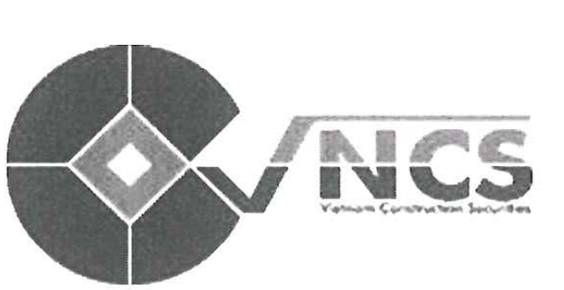 | 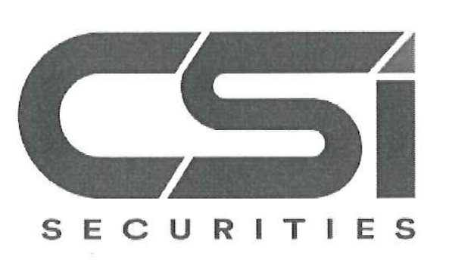

5. Approve amendments and supplements to Charter of the Company in accordance with the change in brand identity
Article 2: Assign the General Director to implement the next steps in accordance with the law and Charter of the Company
Article 3: Members of the Board of Directors, General Director and Departments of Viet Nam Construction Securities Joint Stock Company are responsible for implementing this Board resolution.

